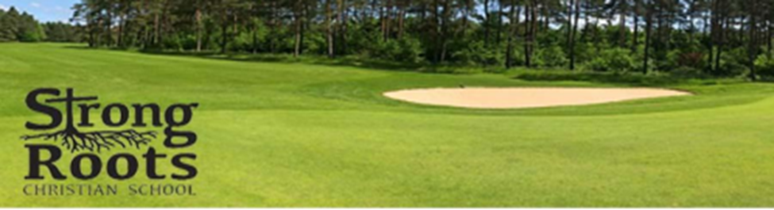
🌿 Strong Roots Christian School
3rd Annual Golf Classic – Sponsorship Opportunities
📅 Date: September 13th, 2025
📍 Location: Deer Run Golf Club; 2305 W 2nd Ave, Indianola, IA 50125
Strong Roots Christian School is proud to host its 3rd Annual Golf Classic, supporting Christian education and student enrichment. We invite you to partner with us as a sponsor for this exciting event and help us cultivate a future rooted in faith, learning, and leadership.

🏌️ Sponsorship Levels
💎 Legacy Sponsor – $10,000
- Event naming rights: “Presented by [Your Company]”
- 3 complimentary foursomes
- Premier logo placement on all marketing materials and event signage
- Display your banner during the week of the event
- Logo on the school’s website for 1 year
- Social media shout- outs
- Verbal acknowledgment during awards presentation
- Opportunity to speak at the event
🥇 Title Sponsor – $5,000
- Prominent logo placement on all event materials and signage
- Recognition as Title Sponsor in all event promotions
- Opportunity to speak at the event
- Two complimentary foursomes
- Logo on the school’s website for 1 year
- Display your banner during the week of the event
- Social media shout-outs
🥈 Champion Sponsor – $3,000
- Logo on event signage and materials
- Recognition as Gold Sponsor in event promotions
- One complimentary foursome
- Logo on the school’s website for 6 months
- Display your banner the week of the event
- Social media mentions
🏆 Platinum Sponsor – $2,500
- 1 complimentary foursome
- Logo on sponsor banner and materials
- Social media recognition
🥉 Gold Sponsor – $1,500
- Company sign at a designated hole
- Complimentary foursome
- Social media recognition

💼 Bronze Sponsor – $500
- Logo on Practice Green
- Logo on Designated Hole

🌱 Friends of Strong Roots – $250
- Recognition on raffle signage and during drawing
- Social media mention
- Any logo merchandise for our golfers the day of the tournament and add your product, gift cards or prizes to the winners.

📅 Deadline for Sponsorship Commitments: August 13th, 2025
Your sponsorship will directly support additional space, and facility improvements, all contributing to a thriving Christian learning environment in our growing school.
Thank you for considering a partnership with Strong Roots Christian School. For more information or to secure your sponsorship, please contact us at:
📞 515-962-5038
📧 golfclassic@strongrootschristian.org

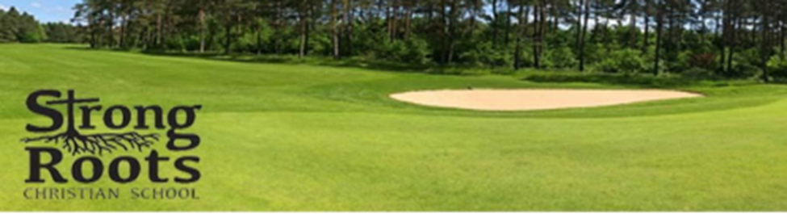
3rd Annual Strong Roots Christian School Golf Classic Sponsorship Opportunities
Thank you for supporting the 3rd Annual Strong Roots Christian School Golf Classic. The event will be held on September 13, 2025, at Deer Run Golf Club. It is our hope that you will join us as a sponsor or as a player in making a difference in the lives of kids in our community.
Company Name_________________________________
Address_______________________________________
Phone number__________________________________
Email__________________________________________
Contact Person__________________________________
Choose Your Sponsorship Level
Sponsor level: _______________________________________________________________
Checks payable to: Strong Roots Christian School
Attention: Golf Classic
2205 West 2nd Ave. Indianola Iowa, 50125
Phone 515-962-5038
golfclassic@strongrootschristian.org
Please keep a copy of this for your tax records: 501(c)3 # 88-1925973
We are educating students in the light of God’s word,
establishing roots for a lifetime of learning, leadership,
service, and worship to the glory of God.

